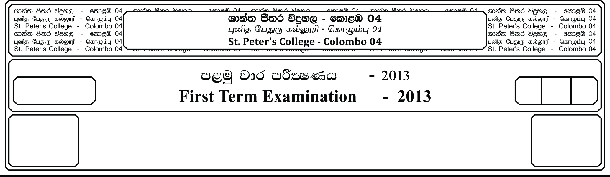

13 fY%aKsh

GRADE 13

13

meh 03

03 Hours

II

**m<uq jdr mÍCIKh - 2024**

**First Term Examination - 2024**

idudkH bx.%Sis - ¸¸

**GENERAL ENGLISH - II**

E

**Part - II**

**01. Chose the words that best complete the sentences in the text.**

Public opinion polls show that crime is **(1).** _______________ as one of the most serious problems of many societies. Yet **(2).** _______________ studies have revealed that the **(3).** _______________ of violent crime is **(4).** _______________. Our peculiar awareness and fear is largely brought about by the great attention it is **(5).** _______________ in the mass media and also because of violent crime being a popular theme for television series and films. Among the crimes, murder makes the **(6).** _______________ and there is little doubt that homicides still continue to be a **(7).** _______________ question in a number of countries. The various causes of severe crime are being constantly **(8).** _______________ and imunerable reasons for it are being pointed out. Among these are unemployment, drug **(9).** _______________ inadequate police enforcement, ineffective courts, racial discrimination, television and the general **(10).** _______________ in social values.

1. Viewed - believed - alleged - thought

2. Pervading - infiltrating - examining - penetrating

3. Quantity - deal - amount - figure

4. Outspoken - overestimated presupposed - upgraded

5. Granted - awarded - devoted - entrusted

6. Headlines - titles - captions - broadcast

7. Burdening - obstructing - nagging - contending

8. Debated - conversed - uttered - articulated

9. Escalation - abuse - maltreatment - disuse

10. Flop - impediment - short fall - decline

***(10 Marks)***

**02. Fill the blanks with most suitable word from the list given in each sentence.**

1. The students have asked their professor to _____________ making a test until after Christmas.

a). postpone b). interrupt c). await d). terminate

2. The handwriting is completely _____________. This note must have been written a long time ago.

a). inedible b). indelible c). illegible d). unfeasible

3. I haven’t established yet how the affair broke out, but I’m going to get to the very _____________ of it.

a). bottom b). ground c). basis d). threshold

4. Is it possible to _____________ the twin brothers apart?

a). recognizing b). tell c). distinguish d). see

5. Our chances of coming in time for the meeting are rather _____________.

a). slim b). sparse c). tiny d). weak

6. She was given the advantage over the other applicants because of her attractive _____________.

a). look b). vision c). appearance d). sight

7. The did have a _____________ escape. Their car stopped right at the river bank.

a). narrow b). fine c). near d). slight

8. I can’t do whatever I want, because I am still financially _____________ on my parents.

a). determined b). subject c). reliant d). dependable

9. His _____________ of the safety regulations really can’t be ignored any longer.

a). disregard b). unfamiliarity c). carelessness d). inattention

10. The first thing for all of you to remember is that _____________ your duties may result in an instant dismissal.

a). escaping b). neglecting c). resisting d). missing

***(10 Marks)***

**03. Make five sentences from the following words.**

Observe , Vibrant , Kidnapper , Delicious , Humiliate , Unique , Legend ,

Simulate , Terminate , Abandon

__________________________________________________________________________________________________________________________________________________________________________________________________________________________________________________________________________________________________________________________________________________________________________________

***(05 Marks)***

**04. The pie chart below shows the reasons for travel and the main issues for the travelling in Sri Lanka in 2022.**

**Reasons for travel Main issues for the travelling public**

* Visit friends / relatives 🞾 Price of travelling 36%
* Social / recreation 🞾 Safety concerns 19%
* Shopping 🞾 Aggressive drivers 17%
* Personal reasons 🞾 Highway congestion 14%
* To and from work 🞾 Access to public transport 8%

🞾 Space for pedestrians 6%

**Write a summary of the reasons and issues for travelling in Sri Lanka.**

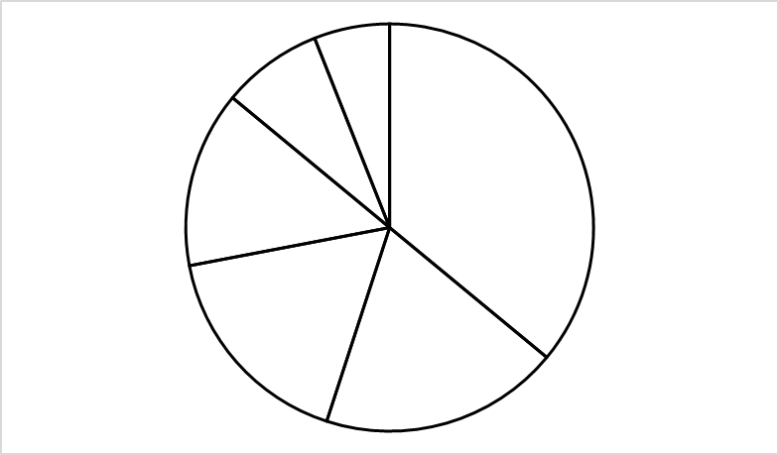

36%

19%

17%

14%

8%

6%

***(10 Marks)***

**05. Complete the dialogue at the cloths shop.**

**Shop Assistant :** How can I help you Sir,

**Paul :** _______________________________________________________

**Shop Assistant :** Are you looking for any brand in particular?

**Paul :** _______________________________________________________

**Shop Assistant :** What colour would you like?

**Paul :** _______________________________________________________

**Shop Assistant :** If you follow me, I will show you some good polo shirts and not very expensive ones.

**Paul :** _______________________________________________________

**Shop Assistant :** How about this one?

**Paul :** _______________________________________________________

**Shop Assistant :** Well, they come in white and blue sir, will a white one do?

**Paul :** _______________________________________________________

**Shop Assistant :** Will that be all?

**Paul :** _______________________________________________________

**Shop Assistant :** That’s Rs. 4500/-

**Paul :** _______________________________________________________

***(05 Marks)***

**06. How do you respond in each of the following situations. Write one sentence or question for each situation.**

1. You are the Managing Director of a company. How do you want an employee to be punctual?

“You__________________________________________________________________

2. You make a complaint at the police station about a robbery at your house. How does the police officer ask you about the robbery?

“Can________________________________________________________________________________________________________________________________________________

3. You want to know the postal charges to send a 500 gr parcel to London, from the postmaster.

Could you __________________________________________________________________

4. You are a salesman in a book shop and a customer wants you to help him to find story book for his Son.

In which grade_______________________________________________________________

5. You want your friend to return a library book for you as you are not well.

Could you__________________________________________________________________

***(05 Marks)***

**07. Read the following poem and do the activities that follow.**

Book! tis a dull and endless strife

Come hear the woodland linnet

How sweet his music! On my life

There’s more of wisdom in it

And hark! How blithe the throstle sings

He too is no mean preacher:

Come forth into the light of thing,

Let nature be your teacher…….

Enough of science and of Art;

Come forth, and bring with you a heart

that watches and receives.

1. Underline the correct answer.

1. The idea conveyed by the poem is,

a). Learning books makes you wise.

b). Only theoretical education doesn’t make you a perfect man with humanistic values.

c). Learning book is nearly enough for perfection

2. What request is made to the reader? Why?

3. What does “he” refer to in the 6th line?

4. Find a word in the poem which means very much the same as the following words.

1. Struggle

2. Cheerful

***(05 Marks)***

**08. Underline the correct answer.**

1. Jenul is not as helpful as Shenal.

a). Shenal is more helpful than Jenul.

b). Jenul is more helpful than Shenal.

c). Both Shenal and Jenul are not helpful.

2. It’s high time we had dinner.

a). We’ve already had dinner.

b). We should have dinner now.

c). There is plenty of time for dinner.

3. Although the bus was crowded, my mother managed to get a seat.

a). Mother did not get a seat, because the bus was crowded.

b). The bus was not crowded, so mother got a seat.

c). The bus was crowded, but mother got a seat.

4. They needn’t have come here today.

a). They did not come here though they should have.

b). They came here though they did not have to.

c). They did not come here, because they did not have to.

5. If Harsha had gone there, he would have met Vikum.

a). Harsha went there, so he met Vikum.

b). Harsha went there, but he did not meet Vikum.

c). Harsha did not go there, so he did not meet Vikum.

***(05 Marks)***

**09. Your friend Mahil is of the view that sex and crime on the television films and serials are responsible for the increase in such violence in the society. You think that the young viewers are sensible enough to take what is real and what is not and therefore such films not at all have any negative impact on the society.**

**Write the conversation that took place between you and your friend in the form of dialogue. Each of you must speak at least five times.**

__________________________________________________________________________________________________________________________________________________________________________________________________________________________________________________________________________________________________________________________________________________________________________________________________________________________________________________________________________________________________________________________________________________________________________________________________________________________________________________________________________________________________________________________________________________________________________________________________________________________________________________________________________________________________________________________________________________________________________________________________

***(10 Marks)***

**10. Read the text and answer all the questions.**

**What do your dreams mean**

I bet that each and everyone of us has had the some dreams: The plane crash, teeth falling out, walk on air, missing that train, falling, drowning, running naked through the streets, being chased... The list go on. But, have your dreams been more vivid since the lockdown? Social media and online forum are awash with stories of vivid dreams and even nightmares. Experts are claiming that there is a lot of truth in this phenomenon. People are sleeping long and this allows more time for dreaming. In addition, the more boring your life, the more your night time brain activity tries to recompense and the more exiting your dreams become.

However, what do those dreams mean? Experts refute that dreams can predict events, but they can help us interpret our feelings. The events in dreams are symbolic. For example, missing that train might indicate that you are feeling left behind, or simply that you are anxious. Walking on air shows that you feel invincible and capable of anything. If you dream that your teeth are falling out or crumbling you have bitten off more than you can chew. Slow down and do less! Dreaming of natural disaster – earthquake, tsunami and volcanic eruption can be intense and terrifying. They show that you are feeling frightened by events outside of your control, like the Corona virus. It is worthwhile to try and decipher your dreams, as this can help you interpret your feelings.

One way to do this is by association. If you dream about people, ask: what does this person mean to me if you dream about, let’s say birds-think: do you love birds or do they make you nervous? Some people claim they never dream; well, they do, but they just forget. It may be useful when you wake up, to try to recall your dream, they might be telling you something important.

**Answer True or False.**

1. Everyone experiences similar dreams ____________

2. There are reports on social media that people’s dreams have become more intense ____________

3. Dreams have become more interesting because life is duller since the lockdown ____________

4. Experts agree that dreams can foretell the future ____________

5. Events in dreams are based on reality ____________

6. Walking on air indicates that you are aiming too high and should be less ambitious ____________

7. Dreaming of dental issues suggests that you should eat more ____________

8. Dreaming about natural disasters indicates that you are happy about the situation around you. ____________

9. It is a useful exercise to try and interpret your dreams ____________

10. Some people never dream ____________

***(10 Marks)***

**11. Answer the questions.**

1. What does the author claim about people and dreams?

__________________________________________________________________________

2. What are social media sites saying about dreams?

__________________________________________________________________________

3. What do experts cite as the reasons for this phenomenon?

__________________________________________________________________________

4. How can dreams help us according to the experts?

__________________________________________________________________________

5. Why should you make the effort to think about what your dreams mean?

__________________________________________________________________________

***(05 Marks)***

***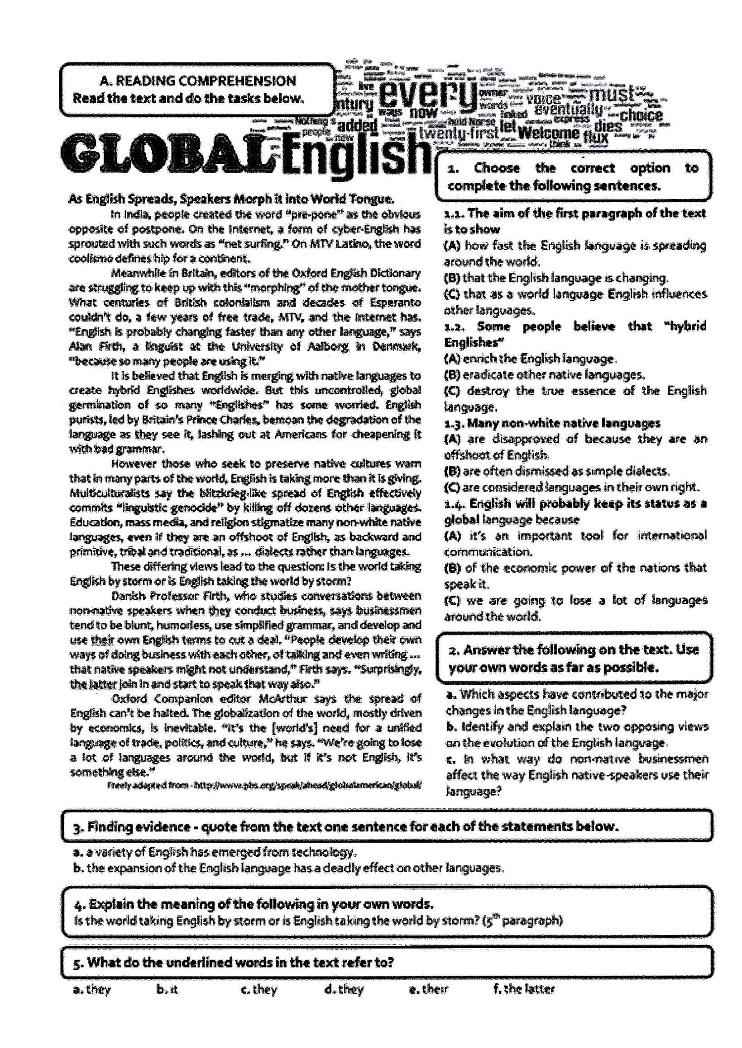*11. Global English. (Reading comprehension) *(15 Marks)***

**12. You travel by bus every weekday morning.**

**Recently you have been unhappy with service. Write a letter to the bus company saying**

* **What the problem is**
* **How it affects you**
* **What you want them to do *(15 Marks)***

**13. Write an e-mail to your best friend offering advice and making suggestions to continue his education after the A/L examination. *(10 Marks)***

**14. Write an essay about “The importance of Education” in 200 words. *(20 Marks)***